Emerald Fundraising
TASK 1: Background
Emerald Fundraising was found in 2024 by Richard Dalgety (fundraised for Action Aid in the past) to provide leading nonprofit organisations with consistent and reliable income streams through high-quality regular giving campaigns. With a strong focus on staff training and development, donor engagement, welcome calling, and innovation at every level, we guarantee our partner charities the best possible return on investment through street, shopping centres, door-to-door, and telephone fundraising campaigns (Dalgety, 2025).
Since launching, we have built a strong foundation in Ireland, successfully partnering with UNICEF Ireland, World Vision Ireland, Dogs Trust Ireland, Plan International Ireland, and Sightsavers Ireland. We have since expanded internationally, including a recent launch in Canada, partnering with Save the Children, and we have more exciting international growth plans for 2026-2027 (Dalgety, 2026).
Our Vision
“Our vision is to be a global leader in face-to-face fundraising for nonprofit organisations that fight poverty, injustice and discrimination(Dalgety, 2026, para 6).”
Our Mission
“To inspire and empower communities through impactful fundraising efforts that support meaningful causes Dalgety, 2026, para 7).”
At Emerald Fundraising, our mission is to provide the best possible service to Irish charities in securing long-term, quality donors. We also aim to provide meaningful careers to passionate individuals from diverse backgrounds. Our management team includes leaders from North America, South America, Europe, Asia, and Africa, spanning the 20s, 30s, 40s, and 50s (Dalgety, 2025).
My role
Working as a fundraiser, I engaged directly with the public—building rapport, sharing powerful stories, and inspiring new long-term supporters of our charity partners.

TASK 2: Payroll/Billing and Commission Process
The process I'll be explaining is the payroll and commission process, from when you receive the 1st paycheck to when you receive your bonuses. I've had jobs like this one, but before, there was no rate per hour, just a commission bonus. But when I was working at Emerald, there was an hourly rate and then a daily bonus if you reached a quota for that day, and then it resets for the following day. Payment is biweekly, paying for the previous 2 weeks, and payments are given to everyone during the same 2 weeks, so no one gets paid one week and vice versa. They schedule induction training on a Wednesday, and then you get paid a week before payroll week for the Thursday and Friday days that you work. By the off chance you start during the week of payroll week, your 1st payment doesn’t happen for 3 weeks. The commission bonus was as follows: if you made 2 people sign up for a charity, you would get an extra €30; 3 people would be €60; 4 would be €90; and so on. This was the daily rate because you had to reach a minimum of 3 sign-ups a week, so the bonus was an incentive to hit targets in a day. And then you would get paid along with the bonus.

TASK 3: Context Diagram
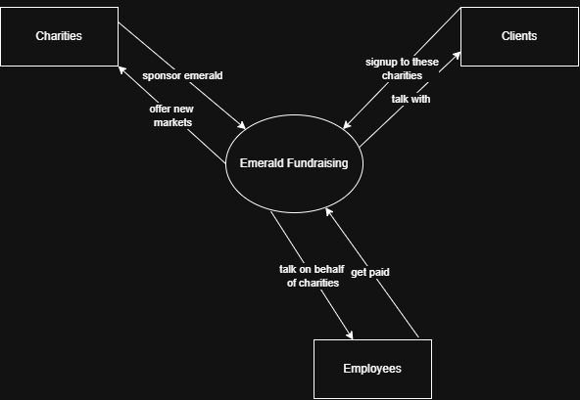

TASK 4: Functional Flow Diagram and Cross-Sectional Flowchart
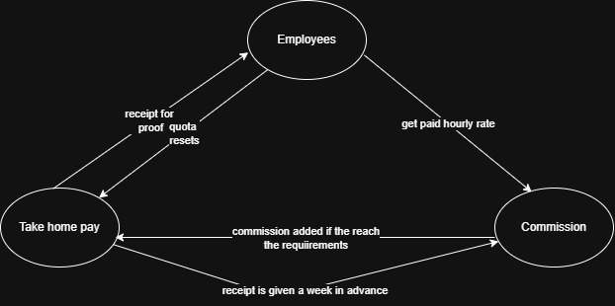

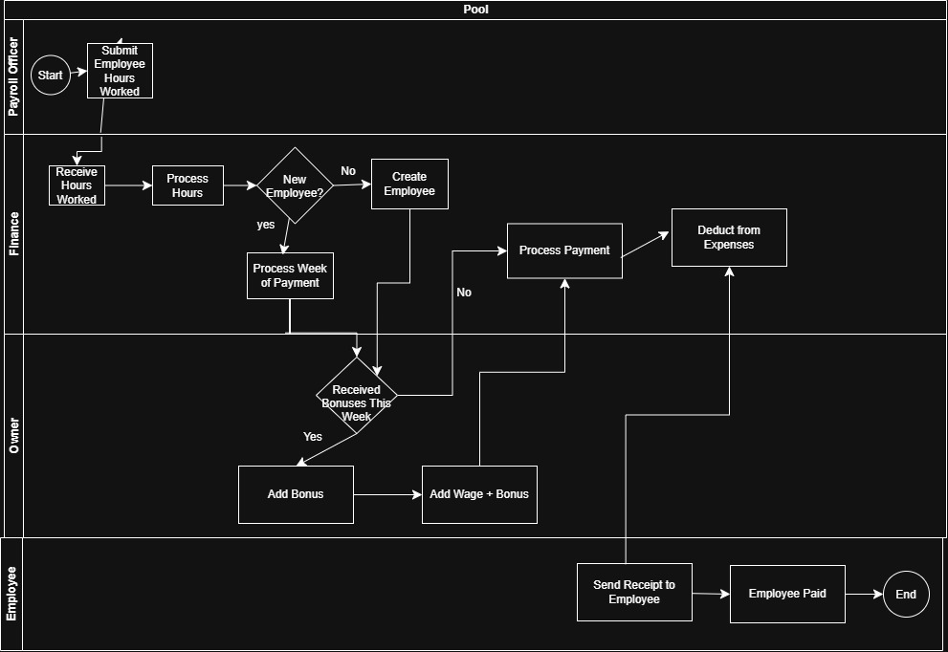

TASK 5: Flowchart
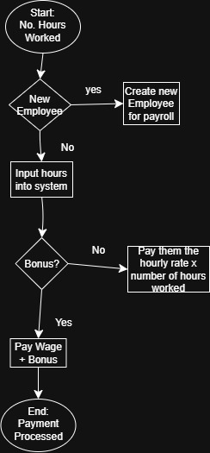

References:
(Dalgety, 2025)
https://emerald-fundraising.com/about
(Dalgety, 2026)
Induction Handbook
(Dalgety, 2026, para 6)
Induction Handbook
(Dalgety, 2026, para 7)
Induction Handbook

